Lecture 1
Rheumatic fever
Objectives:
By the end of this lecture, students should be able to:
➢ Identify the causative organism (post Strptococcal pyogens infection)
➢ Understand the mechanism and pathophysiology of the disease
➢ Recognize the role of molecular mimicry and type II hypersensitivity
➢ State the diagnosis of the disease
➢ Learn the most important preventive measures

Definition: 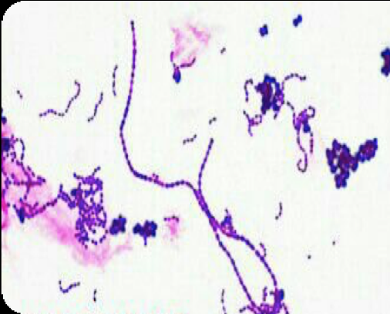
▪ Delayed inflammatory complication of group A β-hemolytic streptococcal (GAS) pharyngitis that usually occurs within 2–4 weeks of acute infection
▪ One of the non-suppurative complications of GAS pharyngitis
▪ Rheumatic heart disease refers to two clinical entities:
• Acute pericarditis :as a sequela of GAS infection
• Chronic cardiac valvular changes :as a complication of acute rheumatic fever

Epidemiology:
• Peak incidence: 5–15 years
• Prevalence
• Developing countries: the most common cause of cardiovascular disease in children and adolescents
• Developed countries: rare

Etiology:
• Most commonly accepted mechanism is Cross-reacting antigens (Molecular mimicry): A number of viruses and bacteria possess antigenic determinants that are similar to normal host cell components. So, the antibodies produced in response to such antigens will react with host tissue (Molecular mimicry) e.g., acute tonsillitis or pharyngitis (“strep throat”) without antibiotic treatment → antibodies formed against M protein of Group A β-hemolytic streptococcus (Streptococcus
pyogenes) (GAS) may cross react with the heart tissues (myosin) and cause rheumatic fever→ type II hypersensitivity reaction → acute inflammatory sequel
• Rheumatic fever is not associated with streptococcal skin infections (e.g.,erysipelas, impetigo, cellulitis).
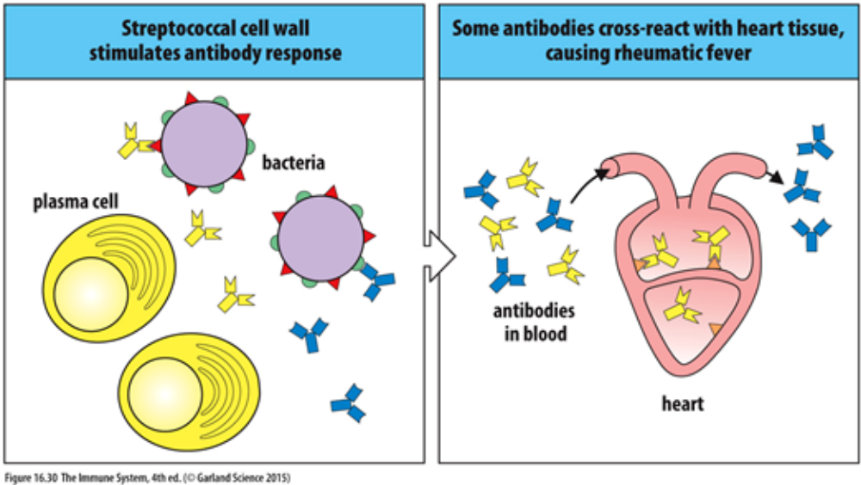

Clinical features:
The symptoms of acute rheumatic fever can be remembered with the JONES criteria,
written with a heart-shaped O: J = Joints, ♥ = Pancarditis, N = Nodules, E = Erythema marginatum, S = Sydenham chorea
▪ Constitutional symptoms: fever, malaise, fatigue
▪ Joints (∼ 75% of cases): migratory polyarthritis
▪ Heart (30–60% of cases)
• Pancarditis (endocarditis, myocarditis, and pericarditis)
• Valvular lesions (Mitral > aortic > tricuspid)
▪ Sydenham chorea: Involuntary, irregular, nonrepetitive movements of the limbs, neck, head, and/or face.
▪ Skin (∼ 10% of cases)
• Subcutaneous nodules
• Erythema marginatum : Transitional flat or barely raised ring-like lesion on trunk . Painless and non-pruritic.
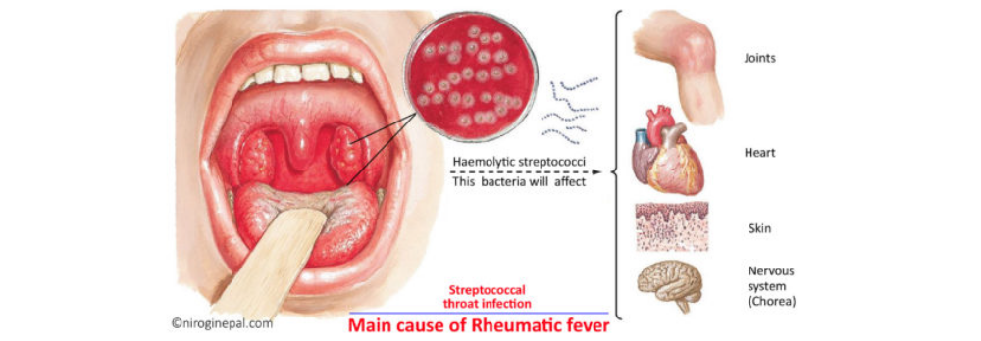

Diagnostics:
▪ Clinical diagnosis :
Diagnosis of acute rheumatic fever is based on the Jones criteria. However, evidence of a preceding GAS infection is also favored.
▪ Confirmation of GAS infection
↑ Antistreptolysin O titer (ASO): antibodies
Positive rapid streptococcal antigen test or throat culture for GAS
1. Specimens: Swabs from throat, or blood for serology
2. Throat Cultures: are done on blood agar incubated at 37ͦ C. Growth and haemolysis is enhanced by incubation at 5-10 % CO2. Colonies producing complete β- hemolysis, catalase negative can be Streptococcus pyogenes.
3. Rapid antigen detection test (RADT): in throat swabs. Negative
result doesn’t confirm the absence of GAS.
4. STREPTOCOCCAL ANTIBODY TESTS:
A raised level of antistreptococcal antibody titers gives us
confirmation about the GAS infection in rheumatic fever patients.
Antistreptolysin O and Antideoxyribonuclease B are the frequently
used antibody assays.
a. Anti-streptolysin O titers get raised within 1 week and it reaches to the maximum level within 3-6 weeks post-infection. A raised level of Antistreptolysin O (ASO) antibody titers (200 units or more) is
CONFIRMATORY.
b. Antideoxyribonuclease B titers get raised within 1-2 week and it reaches to the maximum level within 6-8 weeks.
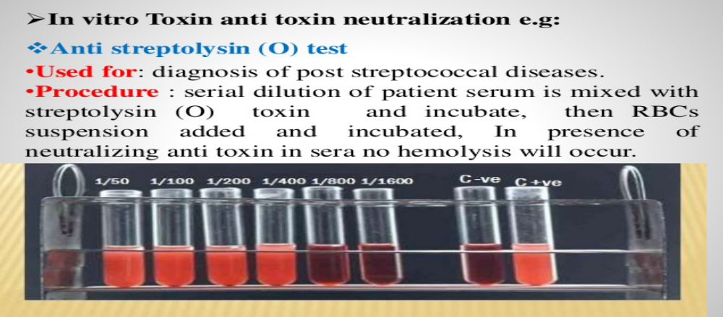
ASOT with titre= 1/400 Todd units
5. PCR based diagnosis assay:
Is used for identifying the Streptococcus pyrogenic exotoxin B gene.
PCR-based diagnosis is more exact than serology and it also helps in early diagnosis of rheumatic heart disease.

6. Acute phase reactants (ESR, CRP): abnormal proteins synthesized in the liver. They appear in the serum and are elevated in cases of active RF as well as in other degenerative and inflammatory conditions. A positive CRP, and a high ESR are helpful in the diagnosis and follow up of cases of RF.
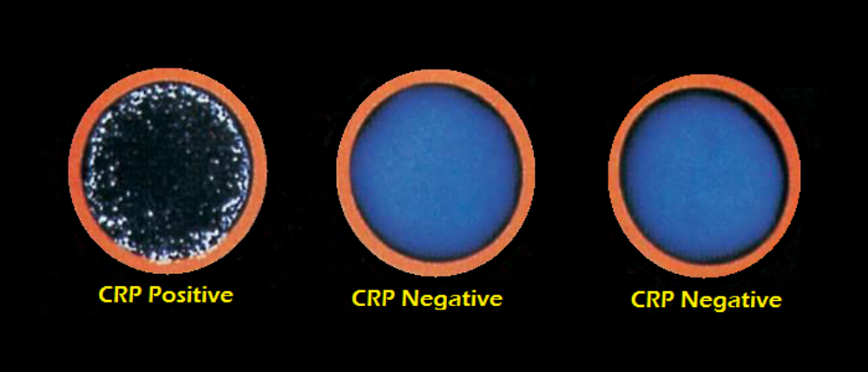
Treatment:
▪ General measures: bed rest (especially important in patients with carditis)
▪ Antibiotics: to eradicate GAS
• Drug of choice: oral penicillin V
• Alternatives:
• Amoxicillin
• Penicillin G IM (in patients unable to complete oral therapy)
• Macrolides (in patients with severe hypersensitivity to beta--‐lactams)
▪ Symptomatic treatment of fever, arthritis and cardiac affection.
▪ Damage to the cardiac valves: Surgery or interventional reconstructive measures may be considered at least one year after the acute inflammatory phase.

Complications:
• Cardiac involvement is the most important prognostic factor.
• Early death in rheumatic fever is usually due to myocarditis.
• Patients with a history of carditis during an initial rheumatic fever episode are at high risk of developing valvular heart defects with recurrent episodes → rheumatic heart disease.

Prevention:
• Primary prevention: prompt antibiotic treatment (e.g., penicillin V) of GAS tonsillopharyngitis diagnosed by throat culture or rapid strep test.
• Secondary prevention
• Antibiotic prophylaxis to prevent recurrence
• Drug of choice: IM penicillin G benzathine
• In patients with a penicillin allergy: oral macrolides
• Usually administered every 28 days
• Immediately follows antibiotic treatment of acute rheumatic fever
• Duration depends on risk and severity of original episode

Lecture 2
Infective Endocarditis (IE)
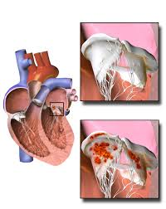

Objectives:
By the end of this lecture, students should be able to:
- List the causative microorganisms associated with IE
- Discuss risk factors of IE
- Discuss pathophysiology of IE
- Outline the clinical presentation and the course of IE
- Discuss the laboratory diagnosis of IE
- Discuss the most common microbiological characteristics of the causative pathogens
- Outline treatment policy of IE.

Infective Endocarditis
Definition: infectious inflammation of the endocardium that affects the heart valves.
Etiology: The condition is a result of bacteremia, which is most commonly caused by dental procedures, surgery, distant primary infections, and non-sterile injections.
Main causative pathogens:
Pathogen | Characteristics
- Streptococcus viridans  - (∼30%) | - Primary habitat is oral cavity and upper respiratory tract  - Most common cause of subacute IE, especially in pre-damaged valves (mainly the mitral valve)  - Common cause of IE following dental surgical procedures  - Produce dextrans that facilitate binding fibrin-platelet aggregates on damaged heart valves
Staphylococcus aureus  - (∼30%) | - Most common cause of acute IE for all groups (including IV drug users, prosthetic valve or pacemakers/ICDs)  - Affects previously healthy valves  - Usually fatal within 6 weeks (if left untreated)  - Large vegetations seen on the valves
- Staphylococcus epidermidis  - (∼11%)  - (Coagulase negative Staph) | - IE transmitted via infected peripheral venous catheters  - Common cause of subacute IE in patients with prosthetic heart valves or pacemakers/ICDs
- Enterococcus faecalis  - (∼ 10%) | - Common cause of IE following nosocomial urinary tract infections (UTIs)  - Following gastrointestinal or genitourinary procedures
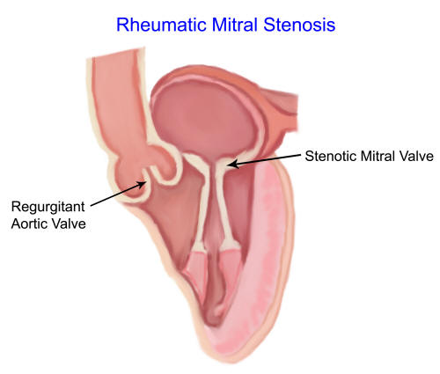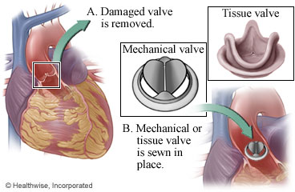
Less common pathogens
Pathogen | Characteristics
- Streptococcus gallolyticus | - Associated with colorectal cancer  - IE in elderly and immunocompromised persons
- Gram-negative HACEK group  - Haemophylus  - Aggregatibacter  - Cardiobacterium  - Eikenella  - Kingella | - Physiological oral pharyngeal flora (∼ 5% of cases of IE)  - In patients with poor dental hygiene and/or periodontal infection  - IV drug users who contaminate their needles with saliva
Coxiella burnetii(5%) | - Endocarditis is a common presentation of Chronic Q fever,a zoonotic disease
Bartonella spp | - Previous cardiac disease (subacute IE)  - Transmitted by arthropods
- Candida species | - Causes IE in immunosuppressed patients. IV drug user  - Causes IE in IV drug abusers  - Cause of IE after cardiosurgical interventions
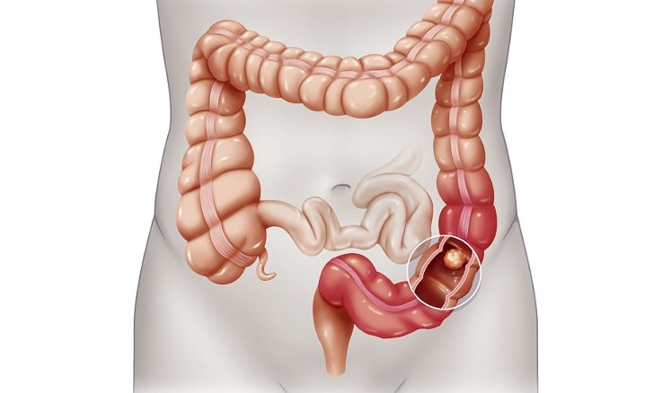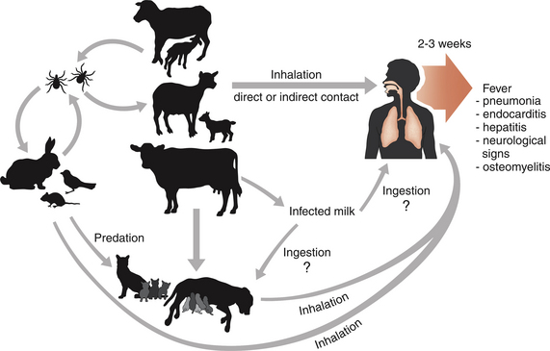

Epidemiology
  - Location
    - Mitral valve > tricuspid valve
    - Tricuspid valve disease is associated with intravenous (IV) drug use
      - Staphylococcus aureus, HACEK, Candida
  - Risk factors
    - Rheumatic heart disease
    - IV drug use
    - Immunosuppression
    - Prosthetic heart valve
    - Congenital heart disease
Pathogenesis
- Factors include turbulent blood flow can cause valvular endothelial damage → deposition of fibrin-platelet aggregate on damaged endothelium. Localized infection or contamination → bacteremia → bacterial colonization of damaged valve areas → further depositions of fibrin and platelets causes vegetations → valve destruction with loss of function
- Preexisting valvular endothelial damage or prosthetic valves predispose to bacterial colonization, especially of those that cause subacute IE
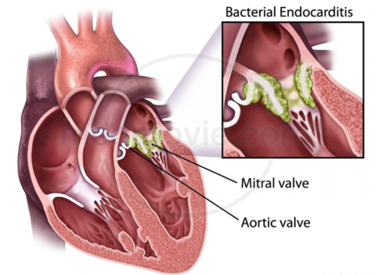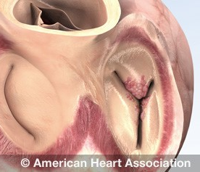

Presentation:
 | Acute bacterial endocarditis | Subacute bacterial  Endocarditis | Prosthetic valve endocarditis
Course | - Acute onset  - Rapid, fulminant progression (days to weeks)  - Severe constitutional symptoms (e.g., high fever | - Insidious onset  - Slow progression (weeks to months)  - Less severe constitutional symptoms (e.g., low fever possible, often absent)  - Affects individuals with pre-existing damage to the heart valves | - Early-onset: < 60 days after surgery  - Late-onset: ≥ 60 days after surgery
Main pathogens | - Most common:  - S. aureus | - Most common: Strept.viridans  - Others: Strept. galloyticus and Enterococci | - Early onset: S. aureus  - Late-onset: S. epidermidis

Clinical features:include constitutional symptoms (fatigue, fever/chills, malaise) in combination with signs of pathological cardiac changes (e.g., new or changed heart murmur, heart failure signs) and possibly manifestations of subsequent damage to other organs (e.g., glomerulonephritis, septic embolic stroke).
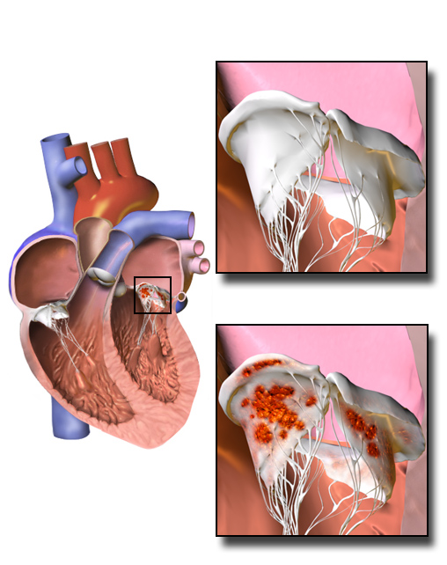
Lab Diagnosis
1-Blood cultures(Before Antimicrobial therapy)
Endocarditis is an endovascular infection with persistent presence of infecting microorganisms in blood. For this reason “Blood Culture” is the standard test to determine the microbiologic etiology of the disease.Three sets of blood cultures are collected from different sites with the first and last samples drawn at least 1 hour apart. Standardblood culture of 5 days period allows recovery of most cultivable microorganisms including Candida and the fastidious HACEK organisms.
Most (usually all) blood cultures from endocarditis patients caused by cultivable organisms should be positive. A single positive blood culture doesNOT typically represent endocarditis pathogen.

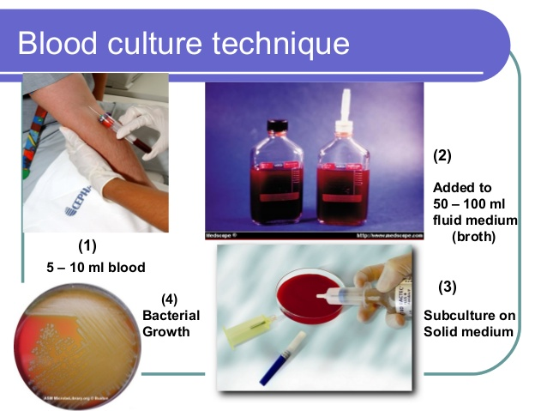

2-Culture characteristics & BR
In positive blood cultures (turbidity), the microbiologist will perform a Gram stain on the blood for a rapid, general identification of the bacteria; Gram’s reaction, bacilli or cocci or yeast.
The blood-broth mixture is subcultured on blood agar plates to isolate the pathogen for identification through culture (on specific plates), gram staining, and biochemical reactions.
Pathogens | Culture Characteristics
Streptococcus Viridans  Gram +ve cocci arranged in chains | - Blood agar: α hemolysis (green coloration)  - Catalase –ve  - Inulin fermentation: -ve  - Bile solubility: insoluble  - Optochin sensitivity: resistant
- Staphylococcus aureus  Gram +ve cocci arranged in clusters | - Endopigment on N. agar & milk agar  - Mannitol salt: yellow colonies dt fermentation  - Blood agar: β hemolysis  - Coagulase & Catalase +ve
- Staphylococcus epidermidis  Gram +ve cocci arranged in clusters | - Endopigment on N. agar & milk agar  - Mannitol salt: pink colonies NO fermentation  - Blood agar: γ(NO) hemolysis  - Coagulase –ve  - Catalase +ve
- Enterococcusfaecalis  - Gram +ve cocci arranged in chains | - Bile Esculin agar: Black colonies  - Blood agar: γ(NO) hemolysis  - Lancefield group D
Candida species  Gram +ve round or oval cells | - Sabouraud’s dextrose agar:Creamy colonies  - Germ tube test  - Sugar assimilation test
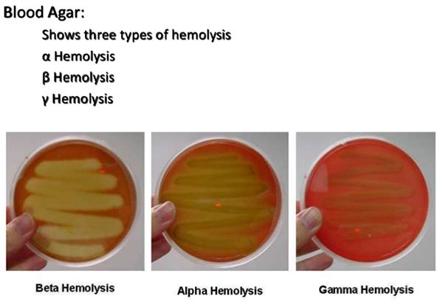
3- Serology: for Coxiella burneti& Bartonella spp, IgG titre ≥ 1:800.
4- PCR: best method for detection Culture Negative Endocarditis (CNE) (blood cultures are negative but echocardiography shows endocarditis).CNE might be caused by: recent administration of antimicrobial therapy,intracellular organisms as Coxiella burnetii & Bartonella spp or fastidious organisms.
5- Antibiotic Susceptibility test:Totailor the antimicrobial therapy according to the susceptibility profile of the causative microorganism.
Management approach
  - Initial treatment of IE consists of empiric IV antibiotic therapy, which is then adapted to blood culture results and continued for four to six weeks.
  - Choice of antibiotics ultimately depends on causative agent and results of then susceptibility testing.
  - Allantibiotics should given intravenously,
  - Vancomycin plus ceftriaxone or gentamicin
  - Vancomycin plus gentamicin and rifampin
- Surgical valve replacement: patients who are refractory to medical therapy.
Prophylaxis:Antibiotics are only administered in specific circumstances, e.g., in patients with preexisting heart conditions undergoing dental or surgical procedures.
Prognosis:If left untreated, infective endocarditis can be fatal within a few weeks.
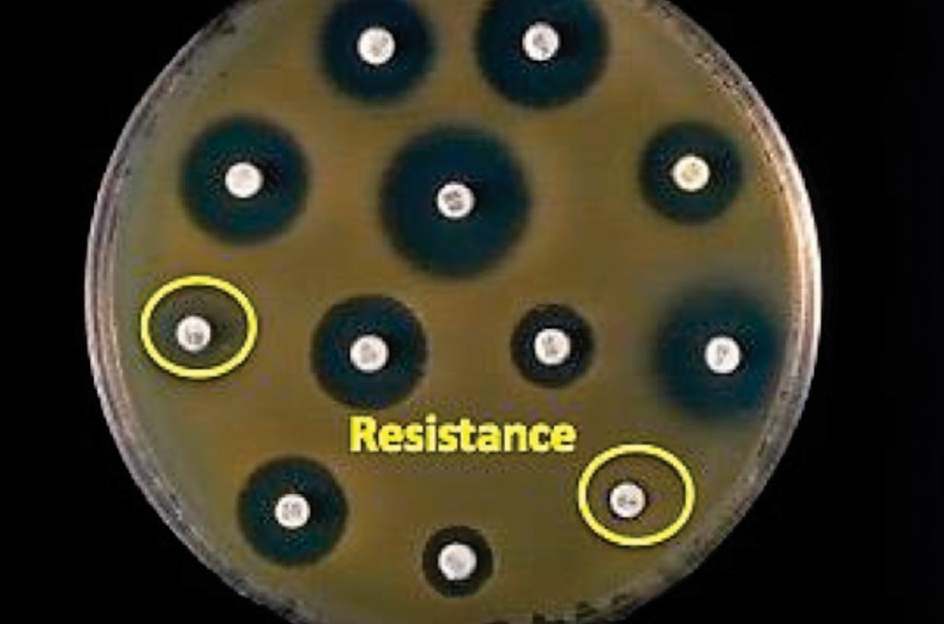

Lectu
Lecture 3
Viral Myocarditis

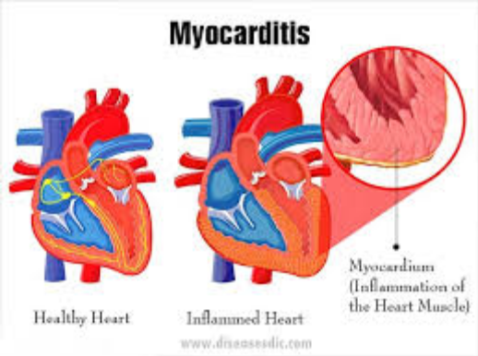
Objectives:
By the end of this lecture, students should be able to:
Learn about the most common viruses causing myocarditis (Coxackie B virus, Parvovirus
B19, Echovirus, & Adenovirus)
Describe the pathogenesis and clinical picture of viral myocarditis
State the laboratory diagnosis of the causative viruses.
Describe important preventive and management measures

Viral Myocarditis

Definition: Myocarditis is an inflammatory disease of the myocardium that most
often affects young patients, causing around 10% of sudden deaths in young adults.

Etiology:
• Coxsackievirus B: most common virus causing myocarditis
An enterovirus that belongs to the Picorna viridae family
Non-enveloped, icosahedral capsid, linear, single-stranded, positive sense
RNA virus

Transmission via oral secretions or feces

Parvovirus B19 Human herpes virus 6
Echovirus Adenovirus
EBV CMV
H1N1 influenza A HCV
Epidemiology
• ∼ 1–5% of viral infections are estimated to have cardiac involvement.
• Often occurs in young patients (more common in children)
• In ∼ 10% of sudden deaths in young adults, myocarditis is diagnosed in the
post-mortem examination.

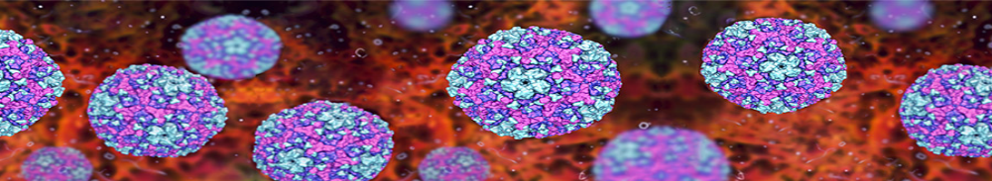
Coxsackievirus, 3D illustration. RNA virus from Picornaviridae family, the genus Enterovirus, causes hand, foot and mouth disease,
meningitis, myocarditis,

Pathogenesis
• Infection through fecal-oral route.
• Once infected, the virus will travel to the lymph nodes and incubate, causing
prodromal symptoms.
• The exact mechanism of coxsakievirus B induced damage to myocytes is
unknown. The likely mechanisms involve immune-mediated and direct viral
cytotoxicity.

Clinical features:
• Adult patients are commonly asymptomatic or present with nonspecific
flulike symptoms, including fever, fatigue, and weakness.
• Some patients also experience cardiac signs that vary in severity from chest
pain to heart failure.
• Infants and children typically have a more severe presentation. Inflammation
may also spread and lead to concurrent pericarditis.
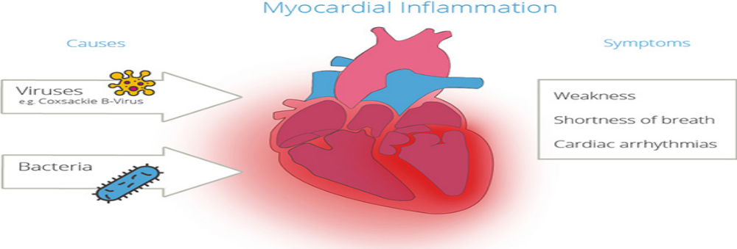
Lab Diagnosis
Viral myocarditis should be suspected in patients with a flulike symptoms and new
evidence of ECG abnormalities. Diagnosis is confirmed with laboratory studies.
A- Viral specific tests:
Virus serology: main diagnostic tool e.g. Coxsackievirus-specific
immunoglobulin by ELISA.
PCR: to detect the pathogen RNA in blood.
Viral culture: tissue culture to detect cytopathic effect.
B- Non-specific blood tests:
↑ Cardiac enzymes
↑ ESR & CRP
Leukocytosis or lymphocytosis

ELISA plate for detection of viral Ig

Viral PCR

Prevention: Common measures to prevent viral infections;
Avoid people with flu-like symptoms.
Follow good hygiene especially regular hand washing.
Management approach: Initial management of myocarditis involves:
Rest & Fluids.
Supportive measures: antipyretics and anti-inflammatories to reduce damage
to the heart muscle.
Cardiac symptoms usually require additional medications.
Specific therapy: IV immunoglobulin and antiviral drugs (interferons &
acyclovir).
Prognosis:
Whereas most adults with viral myocarditis make a full recovery, there is a
small risk of the condition progressing to dilated cardiomyopathy.
The prognosis is especially poor for infants and small children.
CLEAN HANDS COUNTS!!!! Dilated Cardiomyopathy

Other infectious causes of myocarditis:
• Bacterial: β-hemolytic Streptococcus group A (acute rheumatic fever),
Corynebacterium diphtheriae, Borrelia burgdorferi, Mycobacterium
tuberculosis, Mycoplasma
• Fungal: Candidiasis, Aspergillosis

